**Final Report**

**On**

**Room Mart**



Submitted to

**Department of Computer Science and Engineering**

**Nepal Engineering College**

in Partial Fulfilment of the

Requirements for the Degree of B.E. in Computer

By

Bijayan Raj Yadav (020-343)

Bulanda Belbase (020-344)

Sunil Kumar Sah Teli (020-338)

Supervised By: Asst.Prof. Santosh Bhattatai

Date: 09/28/2023

# ABSTRACT

With the current paradigm shift in the technological field, there is an urgent need to embrace and appreciate the power of technology. House renting remains though and time consuming process in the current situation. Hence, Room-Mart (Room renting management system) is necessary to develop so that it can simplify work efficiency and effectively for rental managers and tenants.

The system will be developed in such a manner that it will provide maximum users. There will be two interfaces for logins, one is for owners and another is for renters. Once the user logs in in the system. It will redirect to the different pages according to their selection. Renter can search rooms/flats/houses according to their desired location and facilities. After selecting the post choice renter can book the selected post.

House owners will get notification of booking through a website and email which is provided during registration. This website will be developed using HTML, CSS and Java script.

[**Keywords**: Room finder; Property listings; Rental management system; Online rent;

Room tracking; Ghar bhada; Expenses tracking]

# ACKNOWLEDGEMENT

I would like to express my deepest gratitude and appreciation to all those who have contributed to the successful completion of this project. Without their support, guidance and encouragement, this endeavor would not have been possible.

First and foremost, I am immensely thankful to my friends(name) my project supervisor, for their invaluable guidance and skill throughout the entire project. Their insightful suggestions, constructive feedback, and unwavering support have been instrumental in shaping and direction and outcome of this work.

I extended my sincere appreciation to my colleagues and friends who have been a constant source of motivation, offering their assistance whenever needed. And lastly, I want to thank all and individuals whose work I have referenced throughout this project. Their contributions have formed the foundation of knowledge upon which this work is built.

Table of Contents

ABSTRACT I

ACKNOWLEDGEMENT II

ABBREVIATIONS V

1 INTRODUCTION 1

1.1 Introduction to project 1

1.2 Project description 2

1.3 Challenges of the current systems 3

1.4 Aims and Objectives 4

1.5 Scope of project 5

2 LITERATURE REVIEW 6

2.1 Previous works 6

3 Requirements 7

3.1 Functional Requirements 7

3.2 Non-functional Requirements 7

4 SYSTEM DESIGN 8

4.1 Use case diagram 9

4.2 Data flow diagram 10

4.3 E-R Diagram 12

5 IMPLEMENTATION AND DISCUSSION 14

5.1 Task completed 14

5.1.1 Test case 14

5.2 Schedule Diagram 16

5.3 Output obtained 17

5.4 Tools Used 17

6 CONCLUSION 18

7 REFERENCE 19

Table of Figures

Figure 1: System design 9

Figure 2: Use case diagram 10

Figure 3: Data Flow Diagram 12

Figure 4: E-R diagram for Room Mart 13

# ABBREVIATIONS

|  |  |
| --- | --- |
| **HTML** | Hypertext Markup Language |
| **CSS** | Cascading Style Sheets |
| **PHP** | Hypertext Preprocessor |
| **JS** | JavaScript |
| **SQL** | Structured Query Language |
| **OTP** | One Time Password |
| **API** | Application Programming Interface |

# INTRODUCTION

## Introduction to project

Room mart is the platform to provide the information about rooms, flats and houses which are available for rent. The system aims to simplify the rental process for both property owners and tenants, offering a user-friendly platform to connect peoples. In these modern days it will be easier to get information about rental service through the internet. There will be two pages for landlords and renters. Room mart enhances the overall rental experience by providing centralized hub for listing available rooms, searching for suitable accommodation and managing agreements. Throughout this project report, we will explore the architecture, functionalities, implementation details, and potential enhancements of Room Mart. We will also discuss the benefits it offers to property owners and tenants, emphasizing the system’s ability to improve efficiency, transparency, and communication within the rental market. By implementing Room Mart, property owners can expect increased operational efficiency, improved tenant management, and reduced administrative burdens. Tenants, on the other hand, will benefit from a seamless property search experience, simplified application and payment procedures, and effective channels of communication with property owners.

In conclusion, Room Mart is a renting management system designed to revolutionize the way rental properties are managed. Through its user-friendly interface and comprehensive features, it aims to create a win-win situation for property owners and tenants, fostering a transparent and efficient rental ecosystem.

## Project description

The “Room Mart” project is an innovative platform that aims to revolutionize the process of finding and renting rooms online. It provides a convenient and efficient solution for individuals seeking rental accommodations in various locations. The project aims to create user friendly platform that connects tenants and landlord, offering a convenient and efficient solution for all parties. The main features of Room include:

* Room listing and searching: landlord can easily list their available rooms on Room mart providing detailed information such as price, location, terms and condition. Tenants can search and select suitable accommodations based on their preferences.
* Booking and reservation: Room mart allows tenants to make book online directly.
* Rental agreement management: Room mart provides a rental contracts electronically, eliminating the need of physical paperwork. Owner and tenants can sign and review agreements.
* Tenants and landlord verification: To ensure the safety and trustworthiness of tenants and landlords, Room mart incorporates a verification by national identity card and mobile number. This helps to keep safe from fraud and scammers.
* Communication and reviews: The system offers a communication channel for property owners and tenants to interact and exchange messages regarding rental agreements. Additionally tenants can provide feedback and ratings for their rental experiences.
* Analytics and reporting: Room mart provides reporting functionality to property owner and tenants. This helps to maintain platform more secure and feasible. Report will be studied and take action according to conditions.

## Challenges of the current systems

Some challenges of current systems are given below. Room mart aims to overcome the limitation and challenges.

* Manual and time consuming: many existing platforms for room renting service still rely on manual processes. Like paper work, manual booking, etc. these processes are time consuming and resulting in delays and inconvenience for both owner and tenants.
* Inefficient communication channels: communication between landlord and tenants is not efficient on current platform. This leads to delays in responding to booking, queries, etc.
* Lack of trust and transparency: current platforms may face challenges in establishing transparency and trust between owner and tenants.
* Limited accessibility and scalability: advertisements or local connection, limiting the reach for both parties. Lack of scalability and adaptability to change the current market trends and technology.

## Aims and Objectives

The objectives of room mart web application are as followed:

* Enhance the rental search experience: The project aims to simplify the process of finding rental rooms by offering a user-friendly platform that provides comprehensive search filters, detailed listings, and reliable information about available rooms.
* Increase transparency and trust: The project seeks to establish a transparent rental ecosystem by implementing verification processes for landlords and tenants, ensuring the accuracy of room descriptions the photos, and providing a rating and review system for users to share their experiences.
* Centralized hub: To create a centralized hub for listing, searching, booking and managing rental agreements and to enhance the overall rental experience.
* Enhance the security: integrate secure payment gateways for online booking and transaction. Reduce paperwork and delay.
* Innovation and collaboration: continuously update and enhance room mart based on feedback and trends in industry. Encourage collaboration with industry and owners
* Provide communication channel: Aims to provide communication channel for owners and tenants to interact with each other.

## Scope of project

It can be used by the room seekers to search room and locate rooms. Rental providers or owner can post their advertisement of room, flats, houses along with agreements and fees. Common users also can make booking thus saving their time and money. The system facilitates secure payment transaction. Room mart incorporates a verification of owner and tenants during registration. Room owner and tenants can communicate with each other to interact and exchange messages, inquiries and feedback. The project scope also encompasses the following consideration:

* Database design: Room Mart requires a well-designed and optimized database structures to store and retrieve property listings, tenant information, payment records, and maintenance requests securely.
* User interface design: The system’s user interface should be intuitive, visually appealing, and responsive to ensure a seamless user experience for property owners and tenants.
* Backend development: The backend of Room Mart involves implementing the necessary functionalities, such as user authentication, data processing, and integration with external services such as payment gateways.
* Integration of payment gateway: To facilitates online rental payments, Room Mart integrates a secure payment gateway, ensuring that financial transactions are conducted safely and efficiently.
* Security and Privacy measures: Room Mart must incorporate robust security measures to protect sensitive user information, prevent unauthorized access, and comply with data privacy regulations.

# LITERATURE REVIEW

Currently most landlords advertise their available renting rooms /flats/houses through notice paper, hoarding board or any brokers. Since the system is implemented manually, the response is very slow and not effective as an online system that will be developed in our project. [1]

However, there are no effective strategies and incentives that have been implemented by the government and any private sector. There are some available rental service management systems or websites in the market. For e.g.: gharbeti.com, rentalnepal.com, hamrorental.com, etc. [2]

They provide rental service but all advertisement is managed by admin but not the house owner. So the renter has to contact the admin manually and after that admin will process further to the house owner. This process is not effective as renters can send booking directly to the house owner rather than admin. It will be more effective for both landlords and tenants using the Room mart website that will be a very user-friendly interface. Our main aim is to avoid mediators and brokers by this process. [3]

## Previous works

Hamrobazar, gharbeti.com are one of the most popular and well known examples of room renting service which are mostly manage by admin or some are not user friendly. Most of the people don’t know about online renting services and its benefits. These platforms didn’t solve the issues of renting services problems.

There are lots of platforms present in current time but still renting process is done by physical methods. Room mart is the solution for those problems encountered by current platforms.

# Requirements

## Functional Requirements

As a web application, Room Mart only requires a web browser such as Chrome, Edge, Firefox, Brave, etc. With the help of a web browser, It can be used on desktops.

## Non-functional Requirements

As a dynamic web application developed with the use of PHP web framework, Room Mart has several non-functional requirements as listed below:

* Operating system: windows
* Frontend
* HTML, CSS
* JS
* Backend
* Programming Language: PHP
* External Library: PHPMailer API
* Database Management System: MySQL

# SYSTEM DESIGN

System Design for Room Mart:

* User Management: Implement a user authentication and registration system to allow users to create accounts, log in, and manage their profiles. Include features for profile management, such as editing personal information, viewing rental history, and managing saved preferences.
* Room Listings and Search: Develop a database to store listings with attributes like room type, location, amenities, price, availability dates, and landlord information. Implement a search functionality that allows users to search for rooms based on various filters like location, price range, amenities, and room type.
* Messaging and Communication: Create a messaging system that enables direct communication between landlords and tenant within the platform. Include features like real-time chat, message notifications, and message history for easy and convenient communication.
* Booking and Reservation: Develop a booking system that allows tenants to request room bookings and landlords to accept or decline the requests. Implement a calendar feature that displays room availability and allows landlords to manage their bookings. Integrate a secure payment gateway to facilitate rental payments within the platform.
* Security and Privacy: Ensure data security by implementing industry-standard security measures, such as encryption, secure user authentication, and secure API communication. Company with privacy regulations and establish privacy policies regarding the handling of user data.

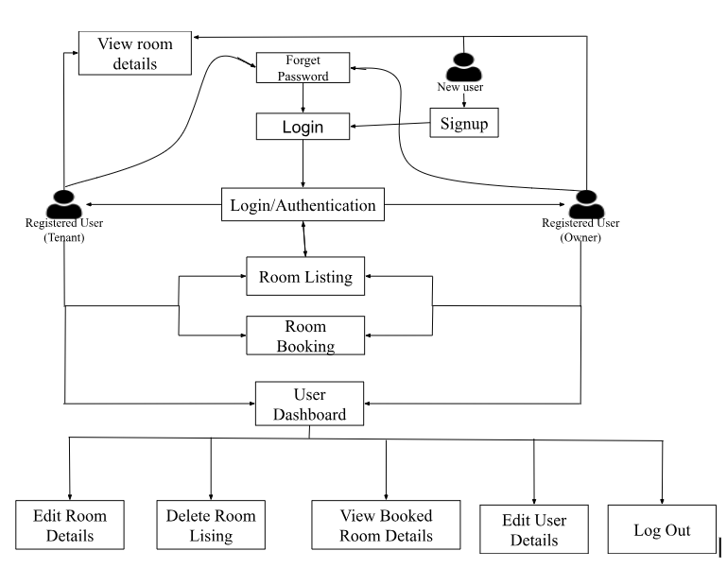

Figure 1: System design

## Use case diagram

A use case diagram for room marts illustrates the various interactions and functionalities between the actors (users and system). Here’s an example of a use case diagram for a room mart system.

The use case diagram provides an overview of the interactions between the actors (users) and the system, highlighting the key functionalities and actions supported by the room mart system.

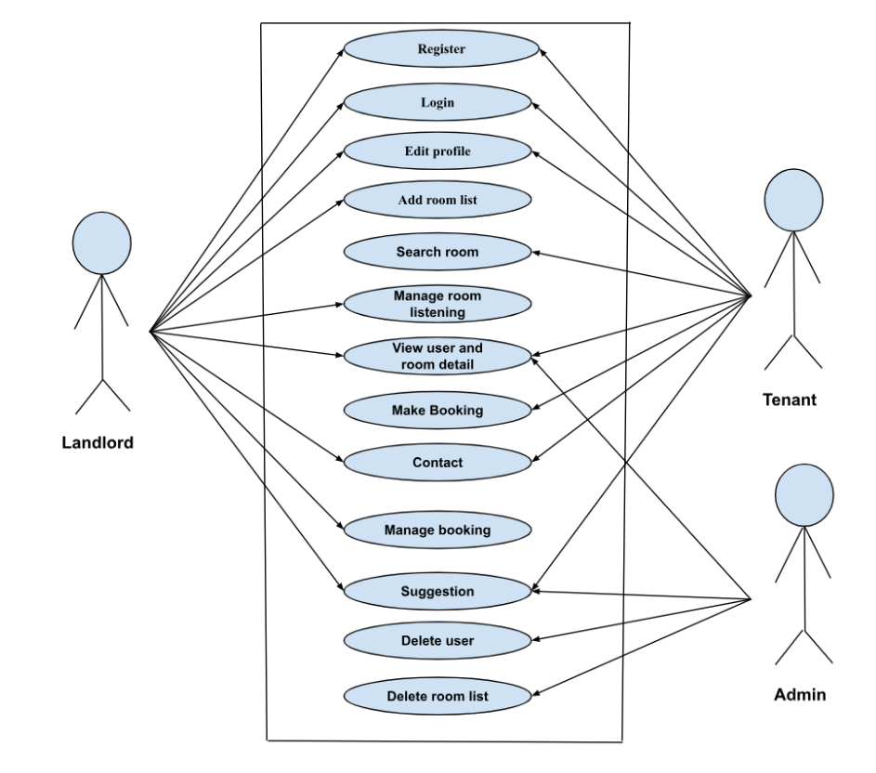

Figure 2: Use case diagram

## Data flow diagram

A data flow chart, also known as a data flow diagram (DFD), represents the flow of data within a system. In the case of a room rent management system, the data flow chart would illustrate the movement

of data related to room rentals, reservations, payments, and other relevant information. A data flow diagram (DFD) for a room mart involving tenants and landlords would illustrate the flow of data and information within the system including inputs, processes, and outputs.

* User Interaction:
* User enters room mart details.
* User makes booking after login
* Reservation Process:
* Reservation details are captures
* Availability check is performed
* Reservation confirmation is sent to the user
* Room Management:
* Room details are stored in a database
* Room availability is checked
* Room status is updated
* User Management:
* User information is stored in a database
* User authentication and authorization are performed
* User profiles are updated

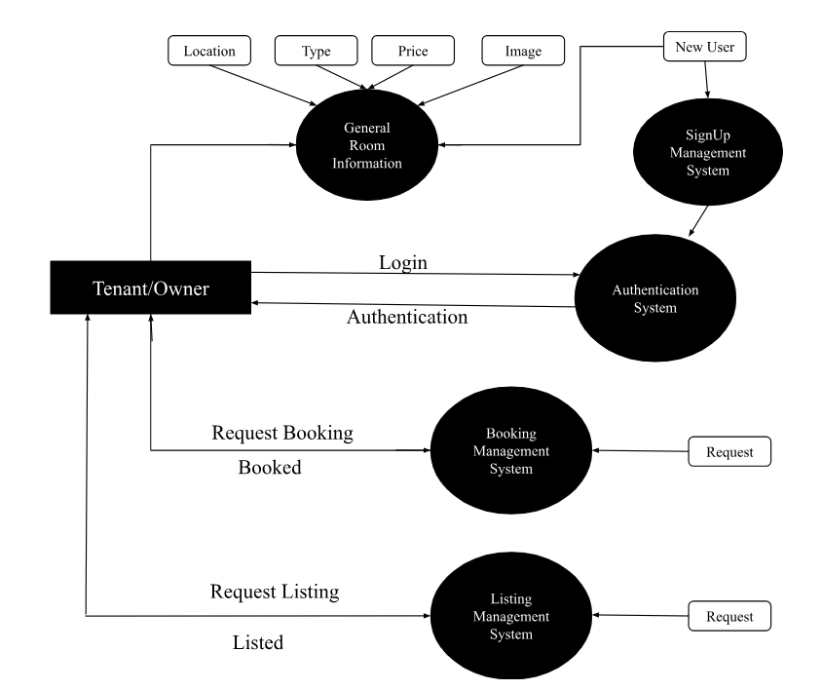

Figure 3: Data Flow Diagram

## E-R Diagram

An E-R diagram visually represents the entities (objects), relationships, and attributes involved in a system. In the context of Room Mart, the following entities and their relationships can be considered:

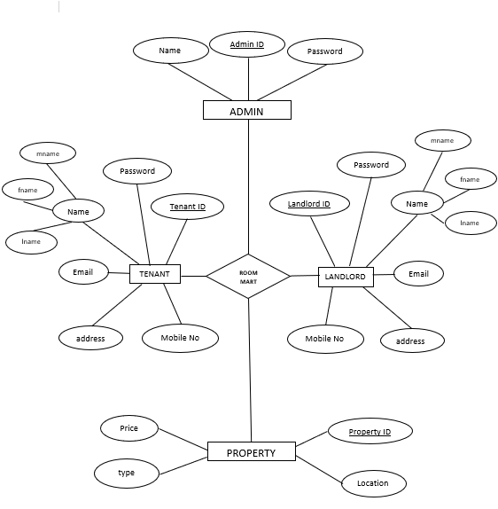

Figure 4: E-R diagram for Room Mart

# IMPLEMENTATION AND DISCUSSION

Room marts mission is to make easier for room searching. We want user interface (UI) to be simple and easy to use.

## Task completed

Basic website design with top navigation bar and home page which include services section, about us section, contact us section. In contact us section website visitors can send information or message or review or suggestion including their name, email and message, which will directly save to database and send mail to admin through email.js API. In the platform customer can enter their details such as their name, email, phone number, address, user type to register. There are verification steps in register form, middle name is not compulsory and new password and confirm password must match and password must be of length of 6 characters and one digit must be included to process registration. Later customer can use the same details to get logged in. If login information match with data in database, they can enter to profile page according to their user type selection.

### Test case

Some test cases to test the registration, authentication, booking, listing, session destroy, editing and deletion are tabulated below.

|  |  |  |  |  |
| --- | --- | --- | --- | --- |
| **Test case** | **Test purpose** | **Test condition** | **Expected outcome** | **Actual result** |
| Account registration | Check for unique email, phone number and validate email using OTP, password minimum length 6, new password and confirm password | If user enter registered email and phone number, display already registered, if password is short or does not match with confirm password disabled submit button | Register user if all validation is confirmed | All validation were performed and checked for user registration |
| login | Check for valid email and password | If user enter wrong information, display error message, and prevent login process | Login user to profile if email and password is valid | Error message displayed in case of wrong info and logged in case of correct info |
| List property | List property asking details of rooms | User required to fill all information and only can submit post request | Post details if all fields are completed | Details posted in case of all details entered and displayed to rooms list page |
| Book property | Book property if login session is true and can see the owner details too | If session is true user can book room and can contact owner too | If all case are true can book room successfully | Successfully booked after login and in case of not login ask to register |
| Editing and deleting user information as well as room details | Check if user is login and can edit if room is not booked, can delete , user can edit user information, can view booked room details | Checking user session and status of room details, if not asked to login or register properly | User can edit, view and delete according to condition applied to system | Successfully performed all action according to session validation and status of room, redirect to login in case of invalid session |
| Session destroy | Check for valid user and protected page can only be accessed by valid session user | In all protected pages user id and session are checked for access | User can access according to session and user id | All protected page were checked for valid user and session destroy in case of logout or invalid access |

## Schedule Diagram

Few lines about Gantt chart about its work done:

|  |  |  |  |  |  |  |  |
| --- | --- | --- | --- | --- | --- | --- | --- |
| Weeks  works | 1 | 2 | 3 | 4 | 5 | 6 | 7 |
| Pre-analysis phase |  |  |  |  |  |  |  |
| Project proposal |  |  |  |  |  |  |  |
| Detailed study and analysis |  |  |  |  |  |  |  |
| Initial prototype |  |  |  |  |  |  |  |
| Implementation of system |  |  |  |  |  |  |  |
| Testing |  |  |  |  |  |  |  |
| Documentation of work |  |  |  |  |  |  |  |

## Output obtained

* User can register to the system with details in signup form
* User can enter login information to enter to their own profile
* User can reset password in case of forget using email OTP
* Owner can post their property with details included
* Tenant can search desired renting property
* User can edit or update profile information
* Validation and authentication system implemented

## Tools Used

* **HTML**

Hypertext is text that is used to reference other pieces of text, while a Markup language is a series of markings that tells web series that style and structures of a document.

* **CSS**

Cascading style sheets (CSS) is a style sheet language which is used to describe the presentation of documents written in HTML. CSS describes how elements should be rendered on screen, on paper, in speech or on other media.

* **PHP**

PHP (Hypertext Processor) is a general-purpose scripting language. The language is used primarily for server-side scripting

* **SQL**

SQL is an open-source relational database management system based on structure query language. SQL run on a virtually in all platform including Linux UNIX and windows although it can be used wide range of application.

* **JS**

It is a lightweight cross-platform and interpreted scripting language. It is used for client-side validation

# CONCLUSION

Thus, our project is meant to satisfy the need of rental house owners and to connect the tenants and house owners to interact with each other for searching rooms/flats/houses. This package shall prove to be powerful in satisfying all the requirements of the users. We hope it will solve all your problems related to the renting system and encourage all to continue appreciating technology because it means to change and ease all the work that seems to be very difficult.

Hence, we can conclude that the software will be highly useful, flexible, user friendly and can be used as an inventory system that can be used by everyone to get suitable rooms/flats/houses. It will save the time for reaching the room and easily route through Google maps. It will help to avoid the intermediate cost as rooms can be booked by themselves. It will encourage the tenants and the owner to use smart technology in the current internet era.

# REFERENCE

1. “https://www.creatrixcampus.com/blog/student-management-system-SMS,”

[Online]. [Accessed 04 Feb 2022].

1. “https://www.trustradius.com/student-management-systems,” 2016. [Online].

[Accessed 2 07 2023].

1. “https://www.slideshare.net/sourabhsinghsen/student-informationsystem103112088,” 18 07 2018. [Online]. [Accessed 05 07 2023].

1. “https://www.studocu.com/row/document/riphah-

internationaluniversity/database/student-management-system-projectreport/12309562,” [Online]. [Accessed 05 07 2023]

